Universidad de las Fuerzas Armadas ESPE
Name: Julio Blacio Machuca
NRC: 27819
Technical review of web pages
- Design Patterns
Expedia
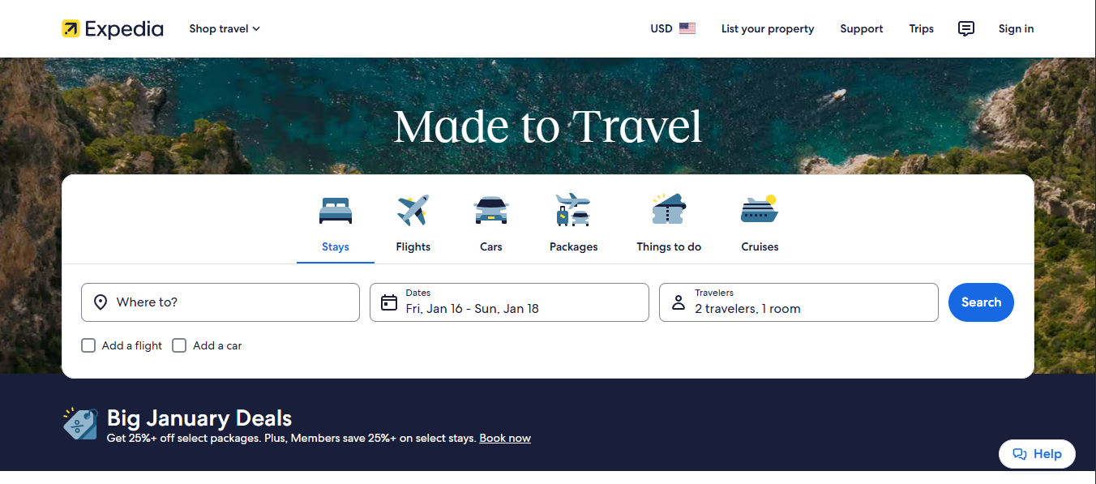
- Modular and Component-based Layout: Expedia employs reusable UI components (search bar modules, date pickers, filters, result cards) that maintain consistency across different sections of the site — a typical modern component design pattern.
- Search-Driven Architecture: The primary design pattern centers around a search funnel: users input basic trip parameters → refine with filters → view results → select options → proceed to booking. This supports progressive disclosure of complexity.
- Feedback and Status Indicators: The interface consistently signals system status (e.g., loading indicators on search, booking confirmations), which aligns with visibility of system status heuristics in UI patterns.
Booking.com

- Task-Oriented Design: Booking.com’s interface is tightly optimized around task flows (search → browse → filter → book). Filters, sorting tools, and dynamic results updates are integral to the design pattern.
- Urgency & Scarcity Cues: UI elements like “Only X rooms left!” or countdown banners create psychological urgency, which is a persuasive design pattern used to increase conversion rates (business-centered UX).
- Consistent Visual Hierarchy: The UI applies consistent typography and spacing patterns that support hierarchical information scanning — a common pattern library approach in large complex ecommerce interfaces.
- UI Design Methods
Expedia

- Heuristic Evaluation: Studies indicate Expedia’s UI follows recognized usability principles (consistency, feedback, error prevention). However, some complexity in filters and promotional elements creates clutter which might impact usability for novice users.
- Aesthetic Minimalism with Functional Focus: Expedia balances functional density with whitespace. Key controls (search fields, date pickers) are prioritized visually, reducing cognitive overhead.
- Responsive & Scalable Design: Elements adjust fluidly across devices (from wide desktops to narrower screens), accommodating diverse user contexts.
Booking.com

- Iterative UI Refinement: The use of bold fonts, default selections, and color accents reflects iterative design decisions aimed at enhancing readability and engagement.
- Experimentation Culture: Booking.com invests heavily in online controlled experiments (A/B tests), refining UI features based on quantitative insights at scale.
- Information-Dense Interfaces: The UI packs a lot of controls and filters in tight layouts, which can be efficient for power users but may overwhelm some users.
- Navigation
Expedia
- Top Navbar with Clear Categories: Expedia’s navigation bar includes distinct categories like Stays, Flights, Cars, Packages, etc., enabling broad exploration at the highest level.
- Breadcrumb-Like Filter Paths: Once users begin a search, navigation shifts to contextual micro-navigation (breadcrumbs, back links, filter tabs) to keep users oriented within results.
- Progressive Navigation Controls: Elements like sticky headers and dynamic filters help users re-orient and re-search without losing context.
Booking.com
- Search-Focused Navigation: Navigation is centered around the search module. Once a destination and dates are selected, filters become the dominant navigational system within the results page.
- Inline Micro-Navigation: Filters (price, rating, amenities) are embedded within the results page, allowing users to refine without leaving the context of results.
- Consistent Global Navigation: Even deep into the site, a persistent top menu enables switching tasks or revisiting core functions.
- Presenting Complex Data
Expedia
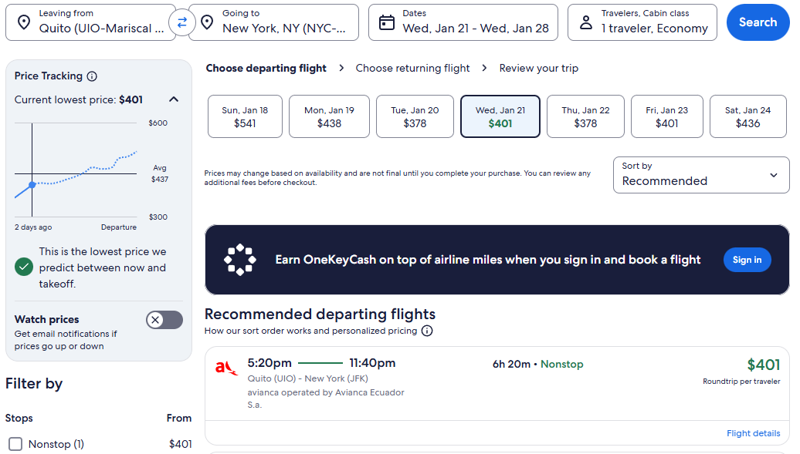
- Price & Availability Displays: Uses card layouts with key details (price, rating, location) to break down complex choices into digestible chunks.
- Interactive Components: Calendars and filters allow incremental refinement of data sets without overwhelming users.
- Visual Hierarchy: Larger textual elements and imagery draw the eye to primary offers, while secondary details (cancellation policies, optional services) are visually de-emphasized unless expanded.
Booking.com
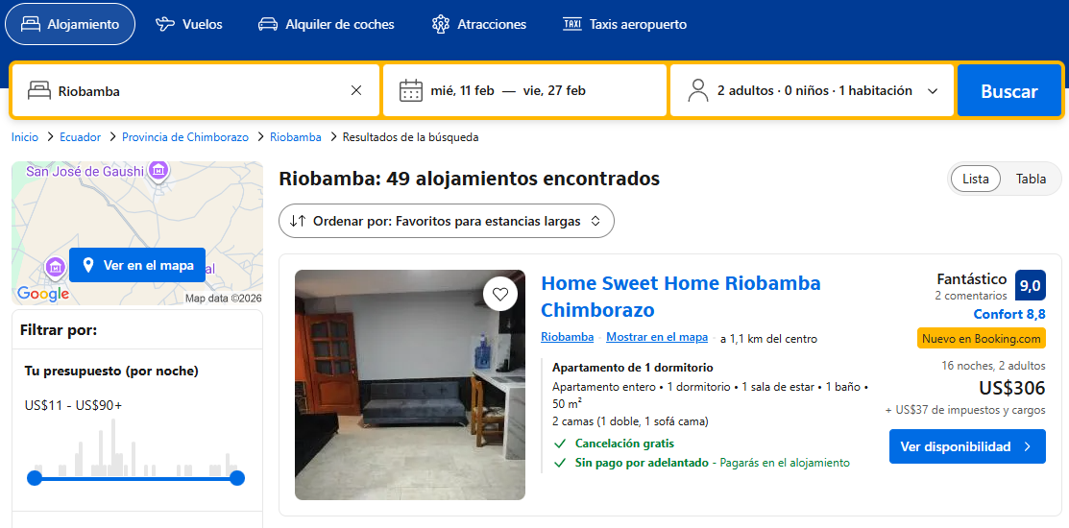
- Multi-Dimensional Filtering: Booking.com surfaces complex data through extensive faceted filters. While powerful, this approach can create a dense UI with steep learning curve.
- Embedded Data Trends: Ratings, price ranges, popularity scores, and user reviews are collated within listing cards, letting users assess multiple dimensions quickly.
- Urgency Metrics: Elements like availability notices embed real-time data into the UI to influence decisions.
- Capturing User Input
Expedia
- Structured Input Forms: Clear search forms gather basic trip parameters (location, dates, travelers). Inputs are validated (e.g., date ranges) before search execution.
- Incremental Refinement: Once initial searches are submitted, the UI offers numerous sliders, checkboxes, and dropdowns to refine search results.
- Helper Feedback: Immediate visual feedback (highlighted errors, hints) reduces input errors.
Booking.com
- Inline Filters & Defaults: Most input interactions occur inside the results page, reducing friction between searching and refining.
- Autocomplete & Suggestions: Search inputs often include real-time suggestions to correct location entries or suggest popular destinations.
- Prefilled Options: Common choices (e.g., dates, number of guests) are optimized with sensible defaults to reduce input load.
- Page Layout & Overall UX
Expedia
- Balanced Visual Focus: Expedia’s layout separates the page into logical regions (search, promotions, content panels) to avoid overwhelming users.
- Whitespace Usage: Effective use of whitespace enhances readability, though promotional banners occasionally compete with primary navigation.
- Functional Rhythm: Repetition of components and consistent placement helps users build mental models quickly.
Booking.com
- Dense, Utility-First Layout: The site’s layout prioritizes functional density, enabling experienced users to scan many options quickly.
- Converted UX Emphasis: Business logic (maximizing bookings) strongly influences layout decisions, sometimes at the expense of minimalist design.
- Visual Consistency: Despite density, consistent button styles, typographic scale, and spacing patterns create predictability.

